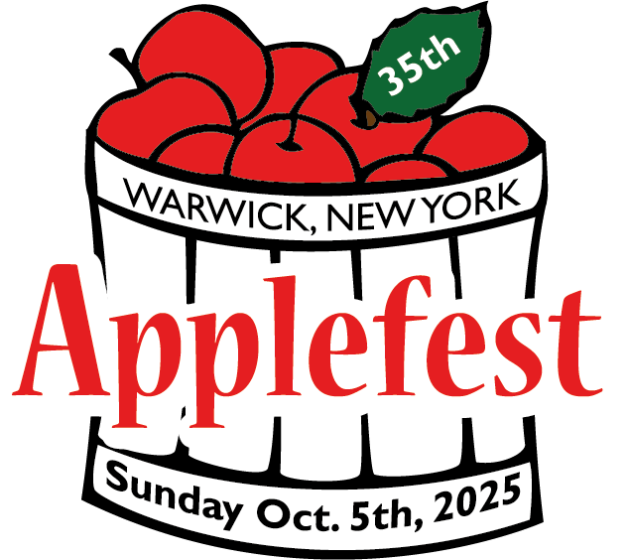

Applefest T-Shirt Design Contest Student Entries Wanted!
- The Applefest T-Shirt Design Contest is open to all Warwick residents, including students. There's a student category, with prizes.
- Entrants are encouraged to submit one or more designs, and the winning design will be printed on t-shirts sold at Applefest.
- If you prefer not to use this as a class activity, please share the information with students, so they may participate individually if they wish.
- The entry form with rules is ATTACHED, or may be downloaded at:
http://www.warwickapplefest.com/
- For EACH entry - complete and attach the bottom of the entry form to the back of artwork. (For class submissions, the stamped, self-addressed envelope for notification is not necessary.)
- For your convenience, class submissions may be placed together in a large envelope marked with your name & school. Please email Info@WarwickCC.org to arrange for pick up before the deadline!
- ALL student entries will be displayed in a Main St. store window before Applefest. After Applefest, your student entries will be returned to your school office.
- Questions – Please reach out to the Warwick Valley Chamber of Commerce Info@WarwickCC.org

This is a fun community project for your students, and we look forward to receiving their creative entries!
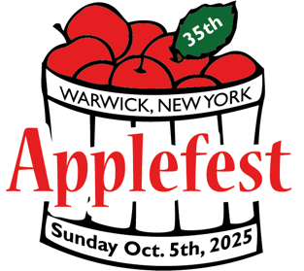 | WARWICK APPLEFEST 2025
T-Shirt Design Contest
Download this form at
www.warwickapplefest.com
OR pick up a copy at the
Chamber of Commerce
FIRST PRIZE –  Adult Category - $50  Warwick Merchant Guild Gift Certificate  Student Category - $20  Warwick Merchant Guild Gift Certificate | SECOND PRIZE  Adult Category - $25  Warwick Merchant Guild Gift Certificate  Student Category - $15  Warwick Merchant Guild Gift Certificate | THIRD PRIZE  Adult Category - $10  Warwick Merchant Guild Gift Certificate  Student Category - $10  Warwick Merchant Guild Gift Certificate

Entry rules:
- Submission deadline – July 11, 2025

- Artwork must be no larger than 12” x 12”

- Contest is open to all Warwick residents, including students
Entrants are encouraged to submit one or more designs
f
- Artwork should be printed out and submitted in no more than four colors (no online submissions)

- ALL three of the following MUST be included in the design:
Applefest 2025 35th Annual Warwick, NY or Warwick, New York

- Artist’s name or signature should appear somewhere at the bottom of artwork

- Complete and attach the bottom of this entry form to the back of artwork
AND paper clip to artwork a self-addressed, stamped envelope (SASE) for notification

- Artwork should be dropped off to the Warwick Valley Chamber of Commerce 75 Main Street Warwick NY 10990

- The winning design will be chosen by the Applefest Committee, whose decision is final

- Questions? – email for quickest response: info@warwickcc.org

Thank you for your participation!

Note – Winning design becomes the property of Warwick Applefest and may be used on additional items and for promotional purposes,
though original artwork will be returned.
✁- - - - - - - - - - - - - - - - - - - - - - - - - - - - - - - - - - - - - - - - - - - - - - - - - - - - - - - - - - - - - - -
Warwick Applefest 2025 T-Shirt Design Contest Deadline - July 11 | Name of artist ⬜ Adult ⬜ Student | Phone | Email address
(Please write CLEARLY!)

